**Student Name: Isabelle Helbig Weight: 5%**

**Student ID: 000898160** **Marks:** **/16**

# Lab: Creating a Simple Webpage

In this lab, you’ll demonstrate HTML development concepts and best practices. This lab may be completed during a provided work period or outside of scheduled class time, as indicated by your instructor.

## Instructions

1. Working individually, re-create a web page that contains the content described below.
2. Uploaded the following to Brightspace:

* Your index.html file
  + A screenshot showing successful validation of your page from <https://validator.w3.org/.>

1. Submit your lab by the due date listed in Brightspace. See the marking criteria below for details on how you will be assessed.

**Page Content**

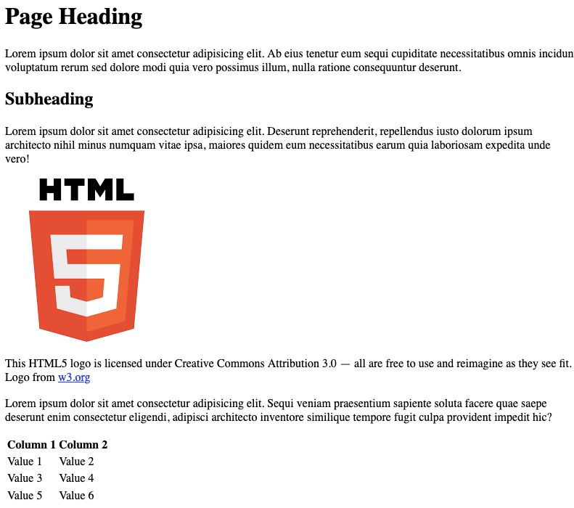

© 2022, Southern Alberta Institute of Technology

**Notes:**

* Generate placeholder text using your text editor or any lorem ipsum generator.
* The HTML logo is available from <https://www.w3.org/html/logo>.

## Marking Criteria

|  |  |  |  |  |
| --- | --- | --- | --- | --- |
|  | **0 Marks** | **1 Mark** | **2 Marks** | **Marks** |
| **HTML Syntax** | No HTML is submitted. | Code is visible on the page. | Page renders without visible errors. | /2 |
| **HTML Syntax** | No HTML is submitted. | HTML has syntax errors. | HTML passes validation with no errors. | /2 |
| **Images** | No image tag element is included. | The image does not appear. | Image renders on page. | /2 |
| **Accessibility** | No images are included. | One or more images are missing alt-text. | All images have descriptive alt-text. | /2 |
| **Linking** | No anchors are included. | Anchor does not work. | Anchor correctly links to another website. | /2 |
| **Tables** | Table is not included. | Table does not render correctly. | Webpage includes a table. | /2 |
| **Tables** | Table is not included. | Inappropriate table elements were used. | Table uses correct elements. | /2 |
| **HTML Attributes** | No HTML is submitted. | Obsolete HTML elements are included. | Appropriate HTML elements are used. | /2 |
| **Total** |  |  |  | /16 |